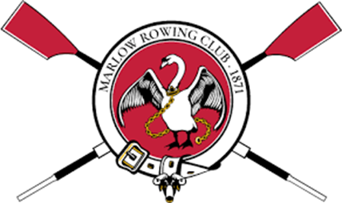

**Marlow Rowing Club**

**Internet and Social Network Policy**

|  |  |
| --- | --- |
| **Version** | 2025/1 |
| **Status** | Approved by the Directors and Committee 6th January 2025. This is a club rule under Article 65 of the Articles of Association and binding on members |
| **Documents Replaced:** This document replaces the following documents which will cease to have effect from the date of this document: | Internet & Social Network Policy (v3, 2015) |

# **Purpose**

This policy covers:

1. Who can run online resources for the club
2. How to behave when using online or social media
3. How the use of social media and the Internet fits with our Welfare System, in particular our **Welfare Policy**
4. How online systems fit with our **Data Protection Policy**

# **Club Channels**

### What they are

Currently the club’s only formal online presence is:

* The website
* Facebook; and
* Instagram

The club’s Twitter/X account is dormant.

The committee may vary these channels at any time.

The official channels may only be posted to by authorised individuals in accordance with club policies.

### WhatsApp / SMS

WhatsApp is a major source of communication within the club. Creation of WhatsApp channels is not controlled, but:

* Welfare Policy rules apply, so 1:1 communication with juniors/adults at risk is subject to controls;
* Welfare Policy and Data Protection Policy rules apply, so personal data and images should not be shared without a lawful basis such as consent or legitmate interests; and
* Where the conversation is a rowing conversation, the BR and MRC Codes of Conduct apply.

Not every conversation on WhatsApp with a person or group you know from rowing is covered by club policies - it has to be part of a club activity or a club/squad channel.Evidence from other WhatsApps or communications may be relevant in an Abuse/Bullying case, where that is relevant to the club, but not for disputes where people merely know each other because of rowing, and particularly where they also interact for other reasons (e.g. go to school together).

1:1 communication should only be carried out with juniors by DBS coaches, only in related to basic rowing information, and should be kept brief. Any concerns should be raised with the CWO and any developed or personal conversations should not occur.

### Any other channel

1. No social media accounts may be set up by members independently of the club without the consent of the secretary which purport to be club accounts or accounts for groups within the club.
2. This policy applies to any groups or accounts set up, whether or not they were authorised.

# **Welfare**

### Images on Club channels

Our Welfare Policy and CWO Policy contain rules about use of photography and the posting of information

# **Data Protection**

In law “personal data” is information from which any person can be identified, so photographs linked to names are personal data controlled by the law. The club is responsible for how personal data is used by the club – see the **Data Protection Policy** for more information.

Photographs of people are generally considered “personal data” in law and therefore the club should only use them where it has consent or one of the other grounds at law. The Club Secretary is responsible for Data Protection any may issue guidance.